ADDITIONAL SAMPLE STATE LAW NOTICES

If the Consumer lives or works in the states and/or cities listed below, please note that additional notices/disclosures may be required by law, and you must provide any applicable notices to the Consumer. We have provided samples of such disclosures in the remainder of this Exhibit:

CALIFORNIA [if Credit Report and/or Investigative Consumer Report]
CITY OF SAN FRANCISCO [If for Employment Purposes]
COLORADO [if Credit Report for Employment Purposes]
CONNECTICUT [if Credit Report for Employment Purposes]
MARYLAND [if Credit Report for Employment Purposes]
MASSACHUSETTS [Additional disclosure required]
MINNESOTA [Additional disclosure required]
NEW JERSEY [Additional disclosure required]
NEW YORK [Additional correction law disclosure required]
NEW YORK CITY [if Credit Report for Employment Purposes]
OKLAHOMA [Additional disclosure required]
OREGON [if Credit Report for Employment Purposes]
VERMONT [if Credit Report for Employment Purposes]
WASHINGTON [if Credit Report for Employment Purposes]

* * * * * * * * * *

SAMPLE STATE DISCLOSURES FOLLOW

* * * * * * * * * *

SAMPLE CALIFORNIA CREDIT CHECK DISCLOSURE DOCUMENT
Pursuant to Section 1785.20.5 of the California Civil Code, the Company informs you that it intends to obtain a credit report about you from Vcheck Global, LLC to evaluate your suitability for employment, or continued employment, in a position falling within one of the following categories. Vcheck Global, LLC may be contacted at 5979 W. 3rd Street, Suite 200, Los Angeles, California, 90036, United States of America. Toll-Free: (888) 740-0747. Information about Vcheck Global’s privacy practices can be reviewed at https://vcheckglobal.com/ (which has its privacy policy).
A position for which the information contained in the report is required by law to be disclosed or obtained;
A position in the state Department of Justice;
A position as a sworn peace officer or other law enforcement position;
A position covered by the executive exemption set forth in subparagraph (1) of paragraph (A) of Section 1 of Wage Order 4 of California’s Industrial Welfare Commission;
A position that involves regular access to bank or credit card account information, Social Security numbers, and dates of birth for any purpose other than the routine solicitation and processing of credit card applications in a retail establishment;
A position where the individual can transfer money or enter into financial transactions on behalf of the Company;
A position where the individual is, or will be, the named signatory on the Company’s bank account or credit card account;
A position that involves access to confidential or proprietary information; or
A position that involves regular access during the work day to $10,000 or more of cash.

SAMPLE CALIFORNIA INVESTIGATIVE CONSUMER REPORT DISCLOSURE DOCUMENT
The Company may order investigative consumer reports as defined by California law on you from a consumer reporting agency (“CRA”) for employment purposes.
Such reports may contain information about your character, general reputation, personal characteristics, and mode of living. To the extent allowed by law, the reports may contain information regarding public records; driving and motor vehicle records; verification of your prior employment, licenses, credentials and education; government watch lists; address history; Social Security number validation; and other background check information.
The Company’s current investigative consumer reporting agency (“CRA”) in California is Vcheck Global, LLC, 5979 W. 3rd Street, Suite 200, Los Angeles, California, 90036, United States of America. Toll-Free: (888) 740-0747. Information about the CRA’s privacy practices can be reviewed at https://vcheckglobal.com/
SUMMARY OF RIGHTS UNDER CIVIL CODE SECTION 1786.22
(a) An investigative consumer reporting agency shall supply files and information required under Section 1786.10 during normal business hours and on reasonable notice.
(b) Files maintained on a consumer shall be made available for the consumer’s visual inspection, as follows:
(1) In person, if he or she appears in person and furnishes proper identification. A copy of his or her file shall be available to the consumer for a fee not to exceed the costs of duplication services provided.
(2) By certified mail, if he or she makes a written request, with proper identification, for copies to be sent to a specified addressee. Investigative consumer reporting agencies complying with requests for certified mailings under this section shall not be liable for disclosures to third parties caused by mishandling of mail after such mailings leave the investigative consumer reporting agencies.
(3) A summary of all information contained in files on a consumer and required to be provided by Section 1786.10 shall be provided by telephone, if the consumer has made a written request, with proper identification for telephone disclosure, and the toll charge, if any, for the telephone call is prepaid by or charged directly to the consumer.
(c) The term “proper identification” as used in subdivision (b) shall mean that information generally deemed sufficient to identify a person. Such information includes documents such as a valid driver’s license, social security account number, military identification card, and credit cards. Only if the consumer is unable to reasonably identify himself or herself with the information described above, may an investigative consumer reporting agency require additional information concerning the consumer’s employment and personal or family history in order to verify his or her identity.
(d) The investigative consumer reporting agency shall provide trained personnel to explain to the consumer any information furnished him or her pursuant to Section 1786.10.
(e) The investigative consumer reporting agency shall provide a written explanation of any coded information contained in files maintained on a consumer. This written explanation shall be distributed whenever a file is provided to a consumer for visual inspection as required under Section 1786.22.
(f) The consumer shall be permitted to be accompanied by one other person, who shall furnish reasonable identification. An investigative consumer reporting agency may require the consumer to furnish a written statement authorizing the consumer reporting agency to discuss the consumer’s file in such person’s presence.
ADDITIONAL SAN FRANCISCO DISCLOSURE DOCUMENT
If you live or will work for the Company in San Francisco, please review the information below. The rights summarized below have no impact on the rights that federal law grants to everyone, no matter where they live or work. A notice of your rights is available at https://sfgov.org/olse/sites/default/files/FCO%20poster2020.pdf and is copied below for your reference.
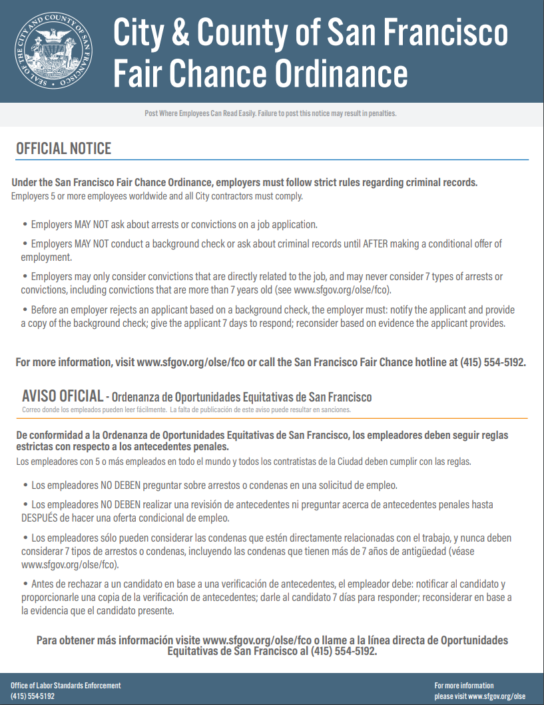
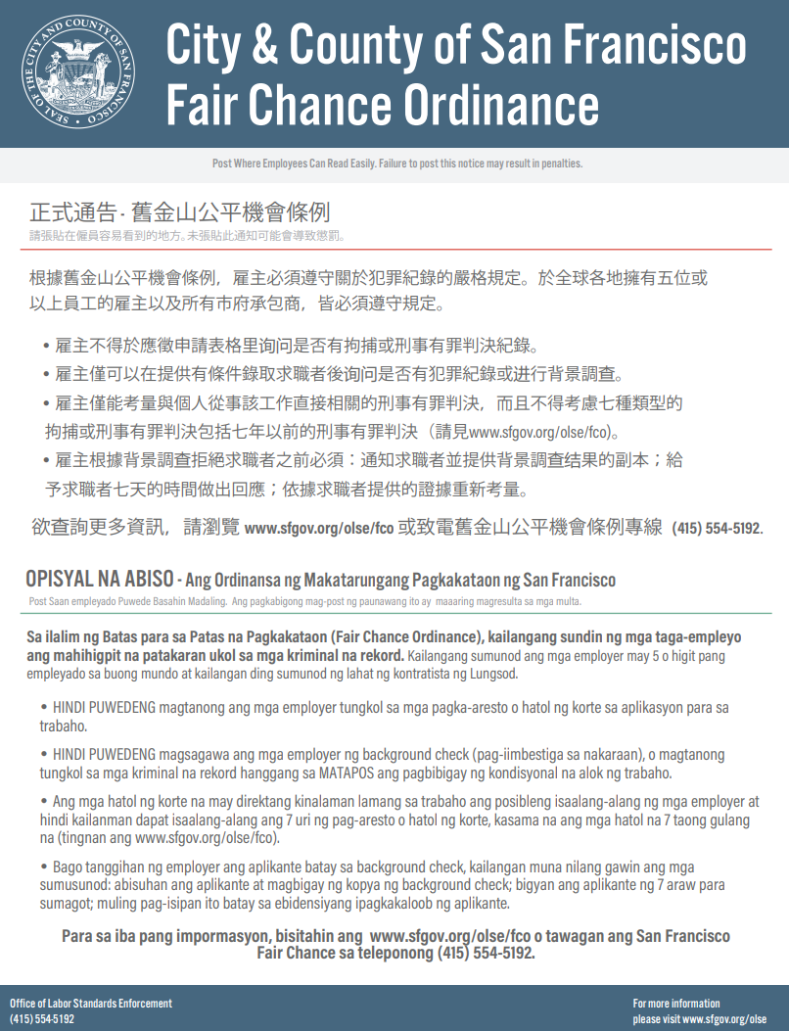

SAMPLE COLORADO CREDIT CHECK DISCLOSURE DOCUMENT
Pursuant to Colorado Revised Statutes Section 8-2-126, the Company informs you that it intends to obtain a credit report about you for employment purposes from a consumer reporting agency because you are seeking to work in a position that:
Constitutes executive or management personnel or professional staff to executive or management personal and the position involves one or more of the following (check each box that is applicable):
Setting the direction or control of the company, a division, or a unit;
A fiduciary relationship to the company;
Access to personal or financial information other than information customarily provided in a retail transaction;
The authority to issue payments, collect debts, or enter into contracts; OR
Involves contracts with defense, intelligence, national security, or space agencies of the federal government;
is with a bank or financial institution.
SAMPLE CONNECTICUT CREDIT CHECK DISCLOSURE DOCUMENT
Pursuant to Connecticut General Statutes Section 31-58tt, the Company informs you that it intends to obtain a credit report about you because you are seeking to work in a position that:
Is managerial and involves setting the direction or control of the Company or a division or unit of the Company;
Involves access to customers', employees' or the Company’s personal or financial information other than information customarily provided in a retail transaction;
Involves a fiduciary responsibility to the Company, including, but not limited to, the authority to issue payments, collect debts, transfer money or enter into contracts;
Is provided an expense account or corporate debit or credit card;
Is provides access to (i) confidential or proprietary business information, or (ii) trade secrets; or
Involves access to the Company’s nonfinancial assets valued at $2,500 or more, including, but not limited to, museum and library collections and to prescription drugs and other pharmaceuticals.
SAMPLE MARYLAND CREDIT CHECK DISCLOSURE DOCUMENT
Pursuant to Maryland Labor & Employment Code Section 3-711, the Company informs you that it intends to obtain a credit report about you because you are seeking to work in a position that:
Is managerial and involves setting the direction or control of a business, or a department, division, unit, or agency of a business;
Involves access to personal information, as defined in § 14-3501 of the Commercial Law Article, of a customer, employee, or the Company, except for personal information customarily provided in a retail transaction;
Involves a fiduciary responsibility to the Company, including the authority to issue payments, collect debts, transfer money, or enter into contracts;
Is provided an expense account or a corporate debit or credit card; or
Involves access to confidential business information or trade secrets.

SAMPLE ADDITIONAL MASSACHUSETTS DISCLOSURE DOCUMENT
If you live or will work for the Company in Massachusetts, please read the information below.
The rights summarized below have no impact on the rights that federal law grants to everyone, no matter where they live or work.
* * *
The Company’s current consumer reporting agency (“CRA”) is Vcheck Global, LLC, 5979 W. 3rd Street, Suite 200, Los Angeles, California, 90036, United States of America. Toll-Free: (888) 740-0747. Information about the CRA’s privacy practices can be reviewed at https://vcheckglobal.com/
If you contact the Company, you have the right to know whether the Company ordered an investigative consumer report about you. You also have the right to ask the CRA for a copy of any such report.
I have received, reviewed and understood this Additional Disclosure Document.
Print name | Date
Signature

SAMPLE ADDITIONAL MINNESOTA DISCLOSURE DOCUMENT
If you live or will work for the Company in Minnesota, please read the information below.
The rights summarized below have no impact on the rights that federal law grants to everyone, no matter where they live or work.
* * *
The Company’s current consumer reporting agency (“CRA”) is Vcheck Global, LLC, 5979 W. 3rd Street, Suite 200, Los Angeles, California, 90036, United States of America. Toll-Free: (888) 740-0747. Information about the CRA’s privacy practices can be reviewed at https://vcheckglobal.com/
Check here to receive a free copy of your report.
You have the right to submit a written request to the CRA for a complete and accurate disclosure of the nature and scope of any consumer report the Company ordered about you. The CRA must provide you with this disclosure within five (5) business days after its receipt of your request or the report was requested by the Company, whichever date is later.
I have received, reviewed and understood this Additional Disclosure Document.
Print name | Date
Signature

SAMPLE ADDITIONAL NEW JERSEY DISCLOSURE DOCUMENT
If you live or will work for the Company in New Jersey, please read the information below.
The rights summarized below have no impact on the rights that federal law grants to everyone, no matter where they live or work.
* * *
The Company’s current consumer reporting agency (“CRA”) is Vcheck Global, LLC, 5979 W. 3rd Street, Suite 200, Los Angeles, California, 90036, United States of America. Toll-Free: (888) 740-0747. Information about the CRA’s privacy practices can be reviewed at https://vcheckglobal.com/
You have the right to submit a request to the CRA for a copy of any investigative consumer report the Company ordered about you.
I have received, reviewed and understood this Additional Disclosure Document.
Print name | Date
Signature

SAMPLE NEW YORK CITY CREDIT CHECK DISCLOSURE DOCUMENT
Pursuant to N.Y.C. Admin Code 8-102, the Company informs you that it intends to obtain a credit report about you because you are seeking to work in a position:
Required by state or federal law or regulations or by a self-regulatory organization to use an individual’s consumer credit history for employment decisions.
That is a position of police officer, peace officer or position with a law enforcement or investigatory function at the Department of Investigation
That is subject to a Department of Investigation background investigation.
That requires bonding under federal, state or City law or regulation.
That requires security clearance under federal or state law.
That requires regular access to trade secrets, intelligence information, or national security information.
That involves responsibility for funds or assets worth $10,000 or more.
That involves control and access of the Company’s digital security systems.
SAMPLE ADDITIONAL NEW YORK STATE DISCLOSURE DOCUMENT
If you live or will work for the Company in New York, please read the information below.
The rights summarized below have no impact on the rights that federal law grants to everyone, no matter where they live or work.
* * *
The Company’s current consumer reporting agency (“CRA”) is Vcheck Global, LLC, 5979 W. 3rd Street, Suite 200, Los Angeles, California, 90036, United States of America. Toll-Free: (888) 740-0747. Information about the CRA’s privacy practices can be reviewed at https://vcheckglobal.com/
If you contact the Company, you have the right to know whether the Company ordered a consumer report or investigative consumer report about you. Shown above is the CRA’s address and telephone number. You have the right to contact the CRA to inspect or receive a copy of any such report. A copy of the text of Article 23-A of the Correction Law is provided below.
ARTICLE 23-A, NEW YORK STATE CORRECTION LAW
§ 750. Definitions. For the purposes of this article, the following terms shall have the following meanings:  (1) “Public agency” means the state or any local subdivision thereof, or any state or local department, agency, board or commission.  (2) “Private employer” means any person, company, corporation, labor organization or association which employs ten or more persons.  (3) “Direct relationship” means that the nature of criminal conduct for which the person was convicted has a direct bearing on his fitness or ability to perform one or more of the duties or responsibilities necessarily related to the license, opportunity, or job in question.  (4) “License” means any certificate, license, permit or grant of permission required by the laws of this state, its political subdivisions or instrumentalities as a condition for the lawful practice of any occupation, employment, trade, vocation, business, or profession. Provided, however, that “license” shall not, for the purposes of this article, include any license or permit to own, possess, carry, or fire any explosive, pistol, handgun, rifle, shotgun, or other firearm.  (5) “Employment” means any occupation, vocation or employment, or any form of vocational or educational training. Provided, however, that “employment” shall not, for the purposes of this article, include membership in any law enforcement agency.  § 751. Applicability. The provisions of this article shall apply to any application by any person for a license or employment at any public or private employer, who has previously been convicted of one or more criminal offenses in this state or in any other jurisdiction, and to any license or employment held by any person whose conviction of one or more criminal offenses in this state or in any other jurisdiction preceded such employment or granting of a license, except where a mandatory forfeiture, disability or bar to employment is imposed by law, and has not been removed by an executive pardon, certificate of relief from disabilities or certificate of good conduct. Nothing in this article shall be construed to affect any right an employer may have with respect to an intentional misrepresentation in connection with an application for employment made by a prospective employee or previously made by a current employee.  § 752. Unfair discrimination against persons previously convicted of one or more criminal offenses prohibited. No application for any license or employment, and no employment or license held by an individual, to which the provisions of this article are applicable, shall be denied or acted upon adversely by reason of the individual’s having been previously convicted of one or more criminal offenses, or by reason of a finding of lack of “good moral character” when such finding is based upon the fact that the individual has previously been convicted of one or more criminal offenses, unless: | (1) there is a direct relationship between one or more of the previous criminal offenses and the specific license or employment sought or held by the individual; or  (2) the issuance or continuation of the license or the granting or continuation of the employment would involve an unreasonable risk to property or to the safety or welfare of specific individuals or the general public.  § 753. Factors to be considered concerning a previous criminal conviction; presumption.  1. In making a determination pursuant to section seven hundred fifty-two of this chapter, the public agency or private employer shall consider the following factors:  (a) The public policy of this state, as expressed in this act, to encourage the licensure and employment of persons previously convicted of one or more criminal offenses.  (b) The specific duties and responsibilities necessarily related to the license or employment sought or held by the person.  (c) The bearing, if any, the criminal offense or offenses for which the person was previously convicted will have on his fitness or ability to perform one or more such duties or responsibilities.  (d) The time which has elapsed since the occurrence of the criminal offense or offenses.  (e) The age of the person at the time of occurrence of the criminal offense or offenses.  (f) The seriousness of the offense or offenses.  (g) Any information produced by the person, or produced on his behalf, in regard to his rehabilitation and good conduct.  (h) The legitimate interest of the public agency or private employer in protecting property, and the safety and welfare of specific individuals or the general public.  2. In making a determination pursuant to section seven hundred fifty-two of this chapter, the public agency or private employer shall also give consideration to a certificate of relief from disabilities or a certificate of good conduct issued to the applicant, which certificate shall create a presumption of rehabilitation in regard to the offense or offenses specified therein.  § 754. Written statement upon denial of license or employment. At the request of any person previously convicted of one or more criminal offenses who has been denied a license or employment, a public agency or private employer shall provide, within thirty days of a request, a written statement setting forth the reasons for such denial.  § 755. Enforcement.  1. In relation to actions by public agencies, the provisions of this article shall be enforceable by a proceeding brought pursuant to article seventy-eight of the civil practice law and rules.  2. In relation to actions by private employers, the provisions of this article shall be enforceable by the division of human rights pursuant to the powers and procedures set forth in article fifteen of the executive law, and, concurrently, by the New York city commission on human rights.

I have received, reviewed and understood this Additional Disclosure Document.
Print name | Date
Signature

SAMPLE OKLAHOMA DISCLOSURE DOCUMENT
If you live or will work for the Company in Oklahoma, please read the information below.
The rights summarized below have no impact on the rights that federal law grants to everyone, no matter where they live or work.
* * *
You have the right to check this box to receive a free copy of the report the Company obtains.
Check here to receive a free copy of your report.
I have received, reviewed and understood this Additional Disclosure Document.
Print name | Date
Signature

SAMPLE OREGON CREDIT CHECK DISCLOSURE DOCUMENT
Pursuant to Oregon Revised Statutes Section 659A.320 and Oregon Administrative Rules Section 839-005-0080, the Company informs you that it intends to obtain a credit report about you because you are seeking to work in a position:
Involving, as an essential function, access to financial information not customarily provided in a retail transaction that is not a loan or extension of credit; or
That requires the Company to obtain credit history as a condition of obtaining insurance or a surety or fidelity bond.

SAMPLE VERMONT CREDIT CHECK DISCLOSURE DOCUMENT
Pursuant to Vermont Statutes Annotated, Chapter 21, Section 495, the Company informs you that it may obtain a credit report about you, for the following reason(s):
The information is required by state or federal law or regulation;
You seek to be/are retained in a position that involves access to “confidential financial information” (defined as “sensitive financial information of commercial value that a customer or client of the Company gives explicit authorization for the Company to obtain, process, and store and that the Company entrusts only to managers or employees as a necessary function of their job duties”);
The Company is a financial institution as defined in 8 V.S.A. §11101(32) or a credit union as defined in 8 V.S.A. §30101(5);
You seek to be/are retained in a position as a law enforcement officer, emergency medical personnel or firefighter as these terms are respectively defines in 20 V.S.A. §2358, 24 V.S.A. §2651(6) and 20 V.S.A. §3151(3), respectively;
You seek to be/are retained in a position that requires a financial fiduciary responsibility to the Company or the Company’s clients, including the authority to issue payments, collect debts, transfer money or enter into contracts;
You seek to be/are retained in a position that involves access to the Company’s payroll information; or
The Company can demonstrate that credit information is a valid and reliable predictor of performance in your specific position.

SAMPLE WASHINGTON CREDIT CHECK DISCLOSURE DOCUMENT
Pursuant to Chapter 19.182.020 RCW, the Company informs you that it may obtain a credit report about you, and that the Company believes that for the following reason(s) the information is substantially job related:
___________________________________________________________________________
___________________________________________________________________________
___________________________________________________________________________

ADDITIONAL SAMPLE ADDITIONAL WASHINGTON CREDIT REPORT DISCLOSURE

If you live or will work for the Company in Washington, please read the following information.
The rights summarized below have no impact on the rights that federal law grants to everyone, no matter where they live or work.
* * *
If you submit a written request to the Company, you have the right to a complete and accurate disclosure of the nature and scope of any investigative consumer report the Company ordered about you. You are entitled to this disclosure within five (5) business days after the date your request is received or we ordered the report, whichever is later. You also have the right to request a written summary of your rights under the Washington Fair Credit Reporting Act.

I have received, reviewed and understood this Additional Disclosure Document.
Print name | Date
Signature

ADDITIONAL SAMPLE NOTICE FOR EMPLOYMENT POSITIONS COVERED UNDER THE REGULATION OF THE SECRETARY OF TRANSPORTATION OR STATE TRANSPORTATION REQUIREMENTS.

SUMMARY OF RIGHTS UNDER 15 U.S.C. § 1681m(a)

You are hereby provided a summary of the following provisions of 15 U.S.C. § 1681m(a):

  - The Consumer Reporting Agency (“CRA”), Vcheck Global, will prepare the background report for the Company. The CRA is located at and can be contacted at 5979 W. 3rd Street, Suite 200, Los Angeles, CA 90036, toll free number 888-740-0747. The privacy policies for the CRA can be found at its web site at https://vcheckglobal.com/.

  - No CRA utilized by the Company makes adverse decisions relating to your employment, and no CRA utilized by the Company is able to provide any specific reasons to you why an adverse decision relating to your employment may be taken or was taken based on a consumer report.

  - 15 U.S.C. § 1681j provides for the right to obtain a free copy of a consumer report on you from the CRA which prepared your background report, under various circumstances, including but not limited to where you receive notice that an adverse action has been taken toward you based on the consumer report. In that instance, Section 1681j provides a right to a free copy of the report provided that you make the request within 60 days of the date that you received notice of the adverse action.

  - 15 U.S.C. § 1681i provides for the right to dispute with a consumer reporting agency the accuracy or completeness of any information in a consumer report furnished by the agency.

I have received and read the above information.

Print Name:

Signature:

Date:

THE REMAINDER OF THIS PAGE IS INTENTIONALLY LEFT BLANK

